- The job XLUD805 generate the file CFGIBS.LU00.SRT.LUMHCNVF into the STEP01 which is containing flexi & conventional transfer record.
- Now we have to browse the latest version of this file into fileaid. Record layout is CNVREC and it is present into the PDS IPS.PO0144G1.SIRJCL.
- Now we have to take the record which got error out into the excel sheet Flexi Auto conversion errors, which is present into path Z:\CB&A_Programme\000 Team info 2022\Flexi Auto Conversion into the different tab for different date.
- Now we got the error code, we have to check the corresponding error description now. Error descriptions are present into Cobol module LUBMHCNV (This is the flexi module) and LDBMHCNV (This is the conventional Module).
- Now we have to get in into the module and then search with the error code as error code is the four-digit variable so just add zeros before the error code, in the case of 6 is the error code, search into the module with error code 0006.
- If we can’t find error code in into Cobol module LUBMHCNV (This is the flexi module) and LDBMHCNV (This is the conventional Module) then we should check error code in called modules (sub modules).
Example: Error code 0046 couldn’t be found in Cobol module LUBMHCNV.But it is available in called module LUBRATVL
.
- Now update the excel sheet with error description and also we have to update which team is going to take action on that error. If you have any doubt regarding the error description what needs to be placed into the excel sheet and also regarding the team who will take action on it, please connect to Stuart/Nitesh on it.
- Once every information updated into the sheet send it to the team NBSTechnicaladmin@oldmutual.com, below is the mail which I have sent pasting it here for reference.

Note – FOR error code “0005 - UNEXPECTED DATABASE ERROR” check next day in CA-view screen. The policy status will be changed to matured in night batch job as below
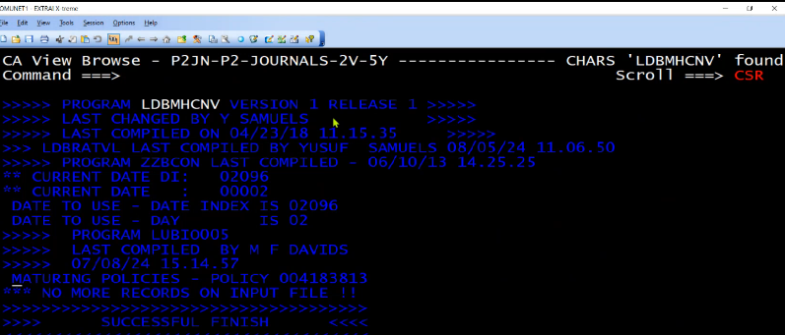

So no actioned required from IT.

Attached mail communication for your reference

